|  |  |
| --- | --- |
| **Roles** | **Responsible Team members** |
| Team Lead | Bharath Kumar Gandhasiri |
| Game Engineer | Neelesh Saladi, Tejaswi Reddy Kandula,  Vineetha Yenugula |
| Application Developer | Tejaswi Reddy Kandula, Neelesh Saladi |
| Marketing Team | Revanth Davuluri |
| Project Manager | Vineetha Yenugula |

Team Members and their roles:

Project Charter

Date 05/15/2020

|  |  |  |  |
| --- | --- | --- | --- |
| **Project Title**: Board Game Development | | | |
| **Project Start Date:** 05/15/2020 **Projected Finish Date:** June 2020 | | | |
| **Budget Information:** This project is approximately leading total cost estimates around $293,050 | | | |
| **Project Manager:** Vineetha Yenugula,  Phone: (660) 528 0503  [S538313@nwmissouri.edu](mailto:S538313@nwmissouri.edu) | | | |
| **Project Objectives:**  To develop a board game by providing user-friendly application and make its availability easy on their own devices. | | | |
| **Success Criteria:**  Before the deadline we will finish our board game application with a bug free, user friendly design and it will be on live with Good Implementation. | | | |
| **Approach:**  **AGILE APPROACH** | | | |
| **Roles and Responsibilities** | | | |
| ***Name and Signature*** | ***Role*** | ***Position*** | ***Contact Information*** |
| 1. Bharath Kumar   Gandhasiri | Team Lead | Team Lead | S538366@nwmissouri.edu |
| 1. Neelesh Saladi | Game Engineer/ Application Developer | Team Member | S538300@nwmissouri.edu |
| 1. Tejaswi Reddy Kandula | Game Engineer/ Application Developer | Team Member | S538309@nwmissouri.edu |
| 1. Vineetha Yenugula | Project Manager/Game Engineer | Project Manager | S538312@nwmissouri.edu |
| 1. Revanath Davuluri | Marketing Team | Team Member | S534917@nwmissouri.edu |
|  | | | |
| **Comments:** (Handwritten or typed comments from above stakeholders, if applicable) | | | |

**Signatures:**

Bharath Kumar Gandhasiri:

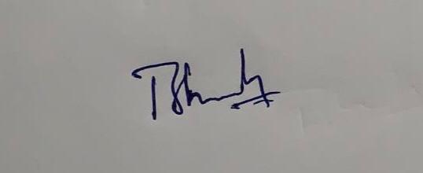

Neelesh Saladi:

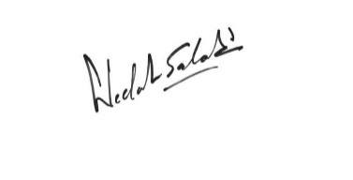

Tejaswi Reddy Kandula:

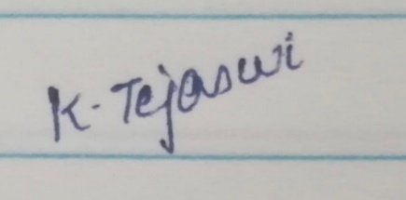

Vineetha Yenugula:

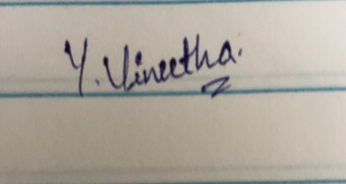

Revanth Davuluri:

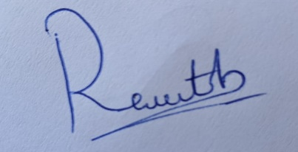

**Project Management Plan Version 1.0**

Date: 05/23/2020

**Project Name:** Board Game Development

**Introduction/Overview of Project:**

This project is about creating a board game application. In this project we will develop a board game as an application where it can be able to use in all machines like mobiles, Laptop, computers etc.., which can be accessible in all operating systems. By this application every user can be able to play board games in their own devices.

**Project Organization:**

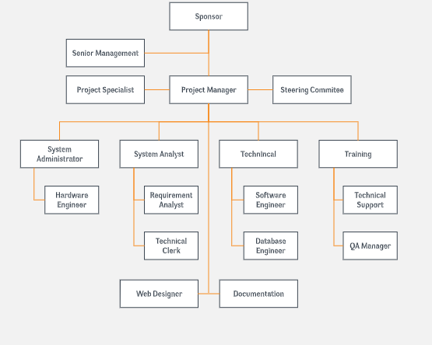

**Management and Technical Processes**

1. **Management Processes:**

**Management Objectives and Priorities:**

* Management is involved at various level while delivering a product. The top most priority of the Management is ensuring that the product is delivered within the time and budget.
* Whenever a new change encounters the Management Team comes into the picture as they are the ones who will decide if the change has to be approved or not.
* It also ensures that the functioning and development of project is processed according to the schedule planned or not.

**Assumptions, Dependencies, and Constraints:**

The project should always satisfy the triple constraints

* scope
* quality
* time

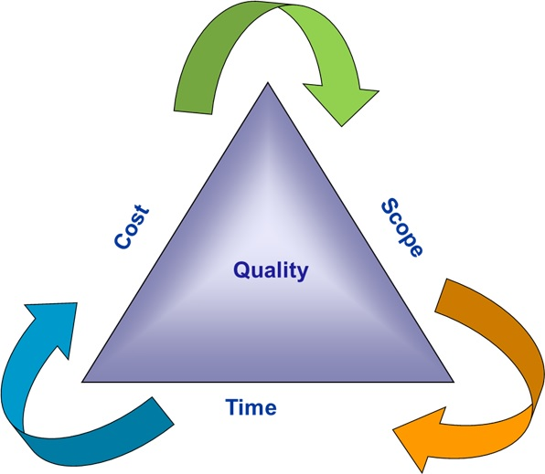

**Risk Management:**

* Project risk management is the process of identifying, analyzing and then responding to any risk that arises over the life cycle of a project to help the project remain on track and meet its goal.
* Risk management isn’t reactive only; it should be part of the planning process to figure out risk that might happen in the project and how to control that risk if it in fact occurs.
* If there’s any kind of risk present in our project, the first thing one has to do is to identify the root cause and try to mitigate the root cause by following necessary risk Management Strategies and this is usually handled by the risk Management team.

**Monitoring and Controlling Mechanisms:**

* [Monitoring](https://www.greycampus.com/blog/project-management/top-4-project-monitoring-steps) and [Controlling](https://www.greycampus.com/blog/project-management/project-control-system) Project Work involves tracking the actual project performance with the planned project management activities. It can mainly be looked as a Control function that takes place at all stages of a project i.e. from Initiation through Closing.
* For small projects, monitoring and control project work is comparatively an easy task. However, as you are aware, Project Management is more stringently required for large projects where the project manager requires a formal effort to monitor and control how the processes are going.
* Monitoring and Controlling Mechanisms are very much important in a project and play a very major role as those mechanisms helps us to check that the project deliverables are properly reviewed. If there’s any kind of issue or any major change these mechanisms can identify and control them thus solving issues throughout the project.

**Staffing Plan:**

The Staffing plan also plays a major role in the project management. The project mainly requires some of the members who play a major role for delivering the product and also for developing the product:

1. Project sponsor
2. Project manager
3. Program Manager
4. System Administrators
5. System Analyst
6. Database analyst
7. Programmers
8. Test engineers
9. Other staff members

1. **Technical Processes:**

**Methods, Tools, and Techniques:**

      We use various methods, tools, techniques in our project such as:

* Microsoft Excel,
* HTML,
* Bootstrap MD,
* React,
* JavaScript,
* Node Js,
* Microsoft Office,
* JIRA.

**Software Documentation:**

* All the documents follow the standard document practices. All the team members strictly adhere to these practices and need to be reviewed by a senior management.
* Documentation is a very important part of Software Engineering. All the Software developed by every individual should be neatly documented so that everyone can understand how the application operates and what standards should be followed while developing a Software.

**Project Support Functions:**

* As we follow the Agile Methodology, Project Manager will be monitoring the application performance and any changes throughout the project Life cycle.
* And also we thought it would be better if we have the Scrum Meetings where the scrum master will be addressing if there are any changes in the current process, it also will help us to track the progress of each task assigned to every individual in the project.

**Work to Be Performed**

* Work packages are the artifacts that cover all the sub tasks per phase wise involved in the project. A work package is the lowest component in a WBS.
* We can create a work package when you decompose a deliverable into components while creating a work breakdown structure.
* This will include all elements, such as a budget, material(s), human resources, schedules, software code, creating the required documents and deliver it to the testing team, milestones and identifying the right technology to be used.

**Schedule Information**

We started our Event Management project on 05/15/2020 and we are approximately expecting the project to be completed by 06/05/2020. The time management plan of the project has detailed schedule of our project completion.

**Budget Information**

The estimated budget of the project is around $293,050. Based on the Project Team, Resources required for developing a project, technologies used the project Manager will allocate all those resources accordingly. The budget and cost information is provided in a detail manner in the cost management plan.

**References to Other Project Planning Documents:**

We have referred to many documents and done a thorough study on how it can be useful to our project Event Management Website. After going through all the articles we obtained various information for our project Management from various sites.